Laporan Teknologi Web

Geometry Calculator



By :

Gede Bayu Saputra

2215101058

Fakultas Teknik dan Kejuruan

Jurusan Teknik Informatika

Prodi Ilmu Komputer

Universitas Pendidikan Ganesha

Singaraja

2023

## CHAPTER I

INTRODUCTION

### Basic Theory

Geometry (from Ancient Greek γεωμετρία (geōmetría) "measurement of the earth"; from γῆ (gê) "earth, earth" and μέτρον (metron) "a measurement") is a branch of mathematics related to the properties of space such as distance, shape, size and relative position of shapes. Geometry, along with arithmetic, is one of the oldest branches of mathematics. A mathematician who works in the field of geometry is called a geometer. Until the 19th century, geometry was almost exclusively Euclidean geometry, which included the concepts of points, lines, planes, distances, angles, surfaces, and curves as fundamental concepts.

Originally developed to model the physical world, geometry has applications in almost every science as well as art, architecture, and other graphics-related activities. Geometry also has applications in fields that seem unrelated to mathematics.

In this report, the objectives to be achieved include:

1. Understand about basic web.
2. Understand about Geometry system.

## 

## CHAPTER II

MAIN CONTENT

HTML (Hypertext Markup Language), CSS (Cascading Style Sheets) and JavaScript are the basic technologies used in web development to create and design websites with interactive features, including Each type serves a different purpose. HTML is the backbone of web content and is used to structure the content of a website. It identifies elements and their relationships on a web page. CSS is used to control the presentation and style of HTML elements. It determines how web content is displayed, including layout, fonts, colors, and spacing. JavaScript is a programming language used to add interactivity and behavior to web pages. It allows you to create dynamic content, respond to user actions, and manipulate your website's Document Object Model (DOM). Here In the context of a geometric calculator, HTML provides the structure and layout of the user interface, allowing users to enter values ​​and view results, CSS can be applied to make the calculator to be visually appealing and user-friendly, and JavaScript JavaScript does the calculations. based on user input, such as calculating the volume of a cube, cube, sphere, etc.

* 1. `<!DOCTYPE html>`: This declaration specifies the document type and version of HTML being used, which is HTML5 in this case.
  2. `<html lang="en">`: The `<html>` element is the root element of an HTML document. The `lang="en"` attribute indicates that the primary language of the document is English.
  3. `<head>`: The `<head>` section of the HTML document contains metadata and links to external resources.
     1. `<meta charset="UTF-8">`: This specifies the character encoding for the document as UTF-8, which is a widely used character encoding for handling various characters and symbols.
     2. `<meta name="viewport" content="width=device-width, initial-scale=1.0">`: This meta tag is commonly used for responsive web design. It sets the viewport width to the device's width and sets the initial zoom level to 1.0.
     3. `<title>Kalkulator Penghitung Bangun Kubus</title>`: This sets the title of the web page, which appears in the browser's title bar or tab.



* + 1. `<link rel="stylesheet" href="style.css">`: This links an external CSS stylesheet named "style.css" to the HTML document. This stylesheet likely contains styles (e.g., for layout, fonts, colors) to be applied to the page's elements.
  1. `<body>`: The `<body>` section contains the visible content of the web page.
     1. `<div class="from">`: This is a container `div` that wraps all the page content. It's often used for layout and styling purposes.
     2. `<div class="Volume">`: Inside the container, there's a `div` with the class "Volume," which appears to be a section or block of content related to volume calculations for geometric shapes.
     3. `<h1>Aplikasi Sederhana untuk Menghitung Bangun Ruang</h1>`: This is a heading displaying "Geometry calculator."
     4. `<button onclick="calculateVolume()">Calculate</button>`: This is a button element with the label "Calculate." When clicked, it triggers the JavaScript function `calculateVolume()`, which should be defined in the linked "script.js" file.
     5. `<div id="dimension-inputs"></div>`: This empty `div` may be used to display input fields specific to the selected shape. These input fields would likely appear dynamically based on the user's choice.
     6. `<label for="answer">The Answer: </label>`: Similar to the previous label, this one is associated with an element with the id "answer."
     7. `<div id="result"></div>`: This empty `div` with the id "result" is likely where the calculated volume will be displayed. The content will be inserted into this `div` dynamically via JavaScript.

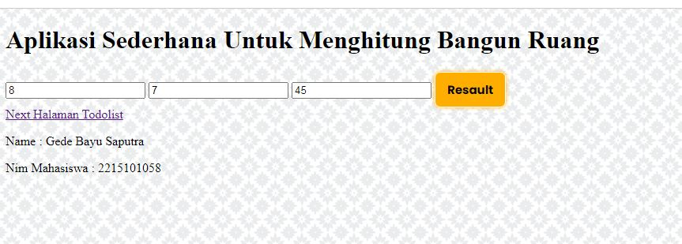

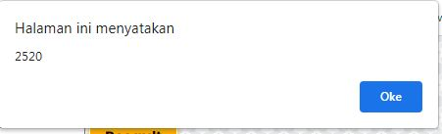

* 1. `<script src="script.js"></script>`: This line includes an external JavaScript file named "script.js." This JavaScript file likely contains the code responsible for calculating the volume of selected geometric shapes and updating the "result" `div` with the result.

1. ***CSS***

The provided CSS code defines styles for various elements within a web page. Here I’ll break down the code step by step:

* 1. `body`:
     1. `font-family`: This property sets the font family for text within the entire web page. It specifies multiple font choices in case the user's system doesn't have the first font listed. The fonts listed are in order of preference.
     2. `background-color`: Sets the background color of the entire page to a light grayish color (#f4f4f4).
     3. `box-sizing`: It ensures that when you set the width or height of an element, it includes padding and borders in the calculation, making it easier to control the layout.
     4. `margin` and `padding`: These properties set the margin and padding of the `body` element to 0, removing any default spacing around the page content.
  2. `button`:
     1. `padding`: Sets the padding of `<button>` elements to 10 pixels vertically and 20 pixels horizontally.
     2. `background-color`: Sets the background color of `<button>` elements to a deep blue color (#301798).
     3. `color`: Sets the text color of `<button>` elements to white.
     4. `border`, `border-radius`, and `cursor`: Define border styling, border radius, and cursor behavior for `<button>` elements.
     5. `transition`: Specifies a smooth transition for the background color when hovering over the button.
     6. `margin-bottom` and `margin-top`: Adds margins at the bottom and top of `<button>` elements.

***c) JavaScript***

The provided JavaScript code is responsible for handling the logic of a geometry calculator web application. It manages user interactions, dynamically generates input fields based on the selected shape, and calculates the volume of various geometric shapes.

## CHAPTER III

CLOSING

### Conclusion

In summary, this HTML code defines a web page for a geometry calculator. Users can choose a geometric shape, enter dimensions if necessary, and then click the "Calculate" button to get the volume calculation displayed on the page. The appearance and functionality are likely further defined and controlled by the linked CSS and JavaScript files ("style.css" and "script.js"). The CSS code defines the styles and layout for elements within a web page, including fonts, colors, backgrounds, spacing, and alignment. These styles are applied to create a visually appealing and responsive user interface for a geometry calculator. And the JavaScript code provides the functionality for a geometry calculator web application. It dynamically generates input fields based on the selected shape, calculates the volume for various geometric shapes, and displays the result when the user clicks the "Calculate" button. It also updates the input fields when the user changes the selected shape from the dropdown.